# Context

## Issue

We have observed challenges among students regarding engagement during lectures, particularly when arriving late or becoming distracted (e.g., by phones) or losing focus. Latecomers often struggle to immerse themselves in the lecture due to the lack of prior information and disruptions caused by trying to catch up. Additionally, instances were noted where students, interrupted by urgent phone calls, left the classroom, resulting in gaps in their understanding as the lecture progressed, or where a student could not focus on the lecture due to other noise from students (see Appendix 5) making it challenging for them to re-engage effectively.

To address these issues, we have developed a system aimed at facilitating student engagement and re-engagement with lectures, thereby enhancing their overall learning experience and as to not repeat disengagement our solution also focuses on maintaining engagement.

Our Design

## Goals

When we say we want to help students engage with the lecture this encompasses the following:

* Engagement with the lecture material
* Engagement with the lecturer
* Engagement with the technologies used – mentimeter, Kahoot etc.
* Engagement of students online
* Engagement of students amongst each other

## Device design

Our system is comprised of 2 devices; Lecture and Student which are identical in design but differ in functionality (see Figure 1). The tablet-sized devices are crafted with a multi-touch interface, ensuring ergonomic comfort and intuitive interaction. Equipped with styluses (see Figure 2) for seamless note-taking and alternative modality use, these devices offer enhanced accessibility for diverse users. By integrating text-to-speech and speech-to-text functionality, individuals with visual impairments or learning disabilities can effortlessly engage with lecture materials (see Figure 3). Additionally, compatibility with Braille displays and tactile feedback mechanisms caters to users who are blind or visually impaired, enabling them to navigate the interface through touch (see Figure 3). The device can be bent in half akin to a flip phone giving users the option for a smaller device (see Figure 4) Furthermore, haptic feedback technology (4) enhances navigation for users with low vision or motor impairments, providing tactile cues during interactions. Gesture recognition capabilities (5) introduce intuitive hand gestures for navigation, particularly beneficial for individuals with mobility impairments (see Figure 5). Moreover, customizable interface settings, such as font size, color contrast, and layout preferences provide a user centered, personalized experience (see Figure 6).

To address security concerns, each device is equipped with innovative GPS technology and an alarm system. In the event of unauthorized removal from the lecture hall, the GPS tracking feature activates, enabling swift recovery. Furthermore, a warning is triggered through an alert on the screen, a low beeping noise and device vibration alerting both the user and nearby individuals to the potential theft. This proactive measure serves as a deterrent while also providing a grace period of five minutes for the device to be safely returned, mitigating inadvertent actions or misunderstandings. If not returned, appropriate authorities are alerted who will handle the situation.

**FIGURE 1**

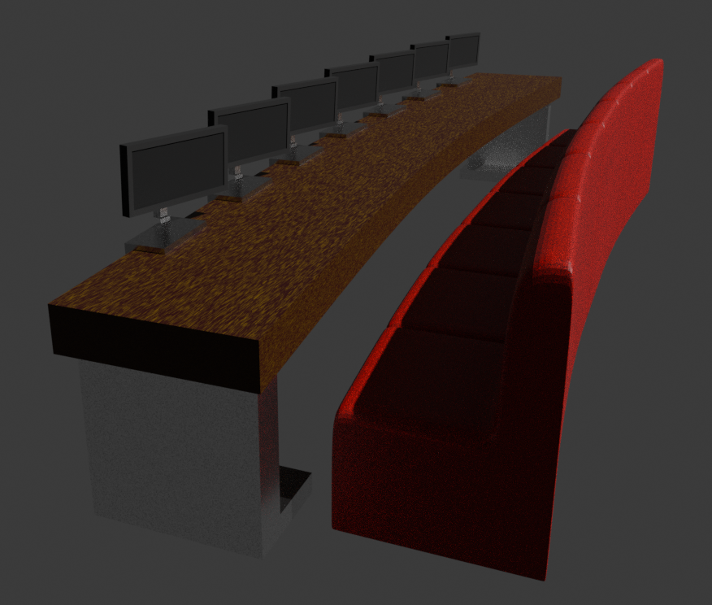

**FIGURE 2**

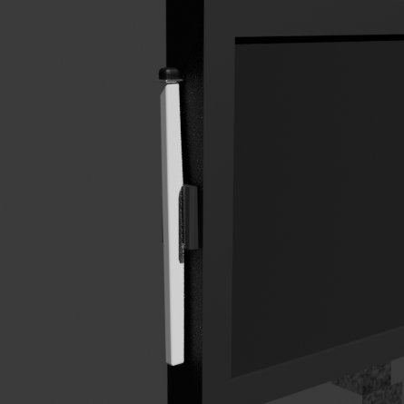

**FIGURE 3**

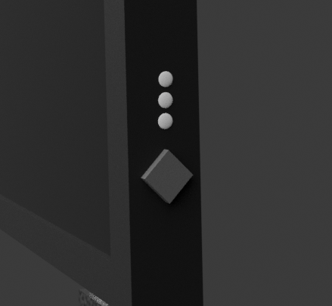

**FIGURE 4**

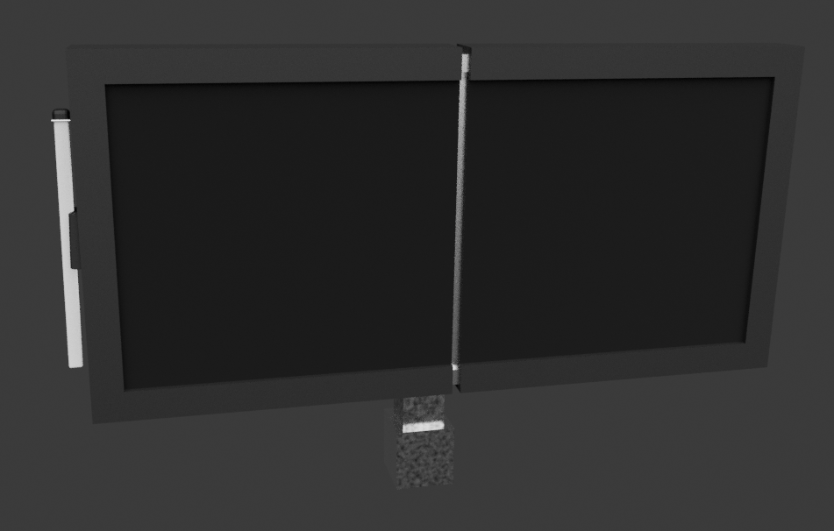

**FIGURE 5**

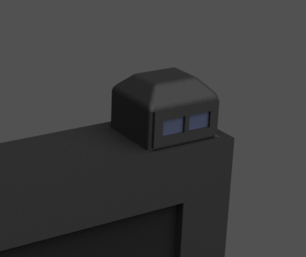

**FIGURE 6**

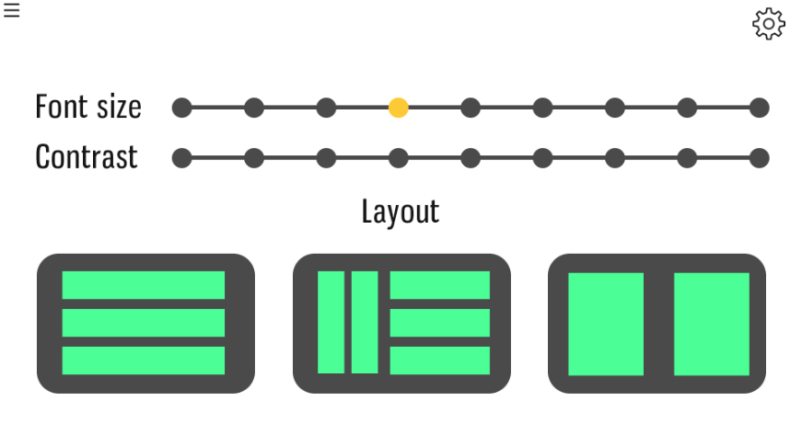

## Device use

The lecturer device serves as the central control unit, initiating the lecture system. It seamlessly synchronizes with student devices, activating them at the onset of the lecture. With access to lecture slides, notes, and supplementary resources curated by the lecturer, the device generates a concise pre-summary, offering students an initial comprehensive preview of the lecture's content (see Figure 7).

Throughout the lecture, the device captures the lecturer's discourse, transcribing it into a comprehensive transcript. This transcript undergoes continual refinement as key points are identified and seamlessly integrated into the evolving summary. This iterative process ensures that students engaging later in the session receive a cohesive and enriched overview. The summary, thoughtfully segmented into topics, facilitates effortless navigation, and fosters a well-organized learning experience. The summary page features an always visible taskbar to the right showing the list of topics. Topics highlighted green are marked as done through the toggle button on the bottom left. Orange highlights the topic they are currently on, while red, the topics they have yet to study. Topics that have yet to be covered by the teacher during that lecture are not displayed but the system will ping the user when available (see Figure 7).

**FIGURE 7**

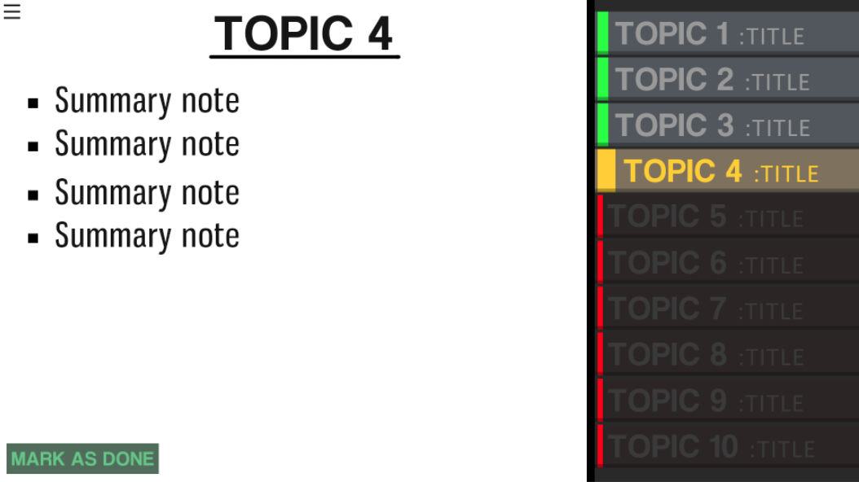

The lecturer may want to hold a Q&A session for assessing students' knowledge. The system utilizes researched memory techniques such as active recall and generates the questions at specific times to ask with the ability for the lecturer to modify. For a more common/known/seen before approach, Mentimeter and Kahoot can be used and are integrated within the device promoting participation and increase engagement with the lecturer and other students (see Figure 8, 9). A hub for other add-ons will be available for the lecturer to add such as

**FIGURE 8**

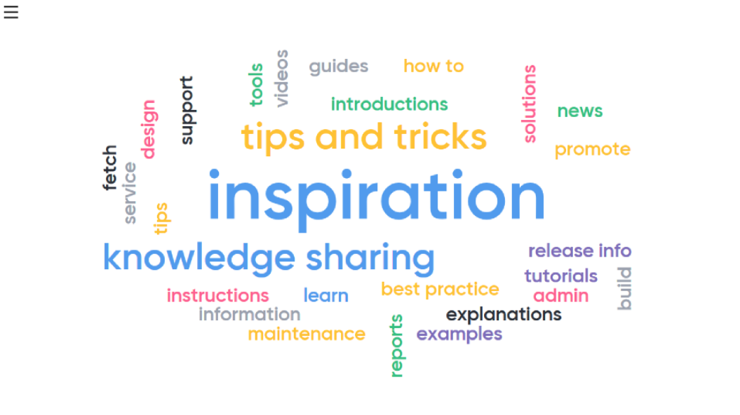

**FIGURE 9**

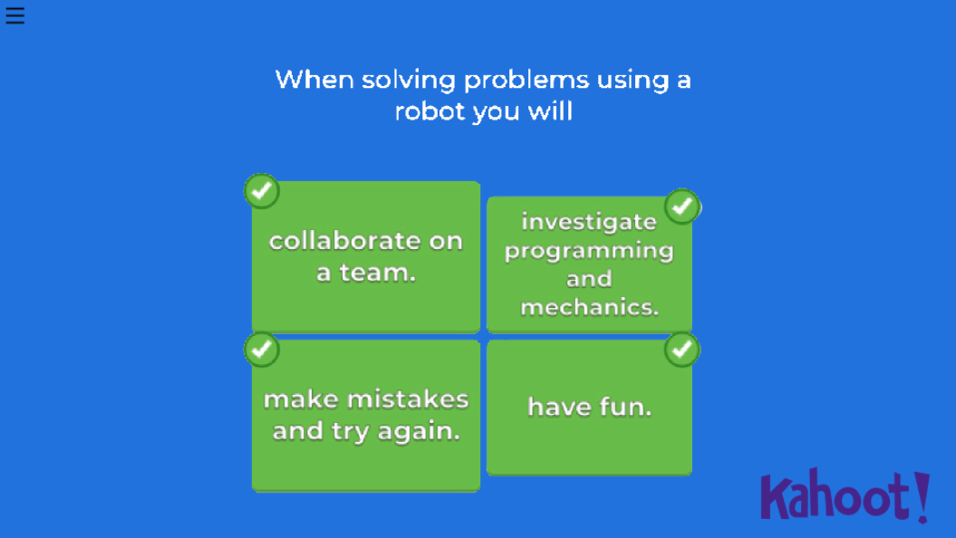

The student interface boasts a welcoming and intuitive design, prompting users to effortlessly scan or input their student ID upon entry (see Figure 10). This feature streamlines the customization process by loading settings preconfigured by the student. Once inside, students are greeted by a selection of buttons offering various functionalities, including access to summaries, notes, and the current slide for easy navigation (see Figure 11). Positioned at the top is a universal search bar, enabling swift keyword searches across all available content.

**FIGURE 10**

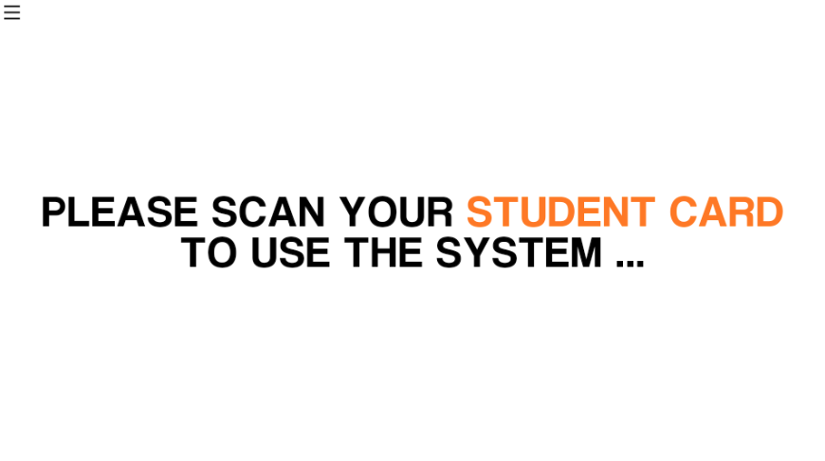

**FIGURE 11**

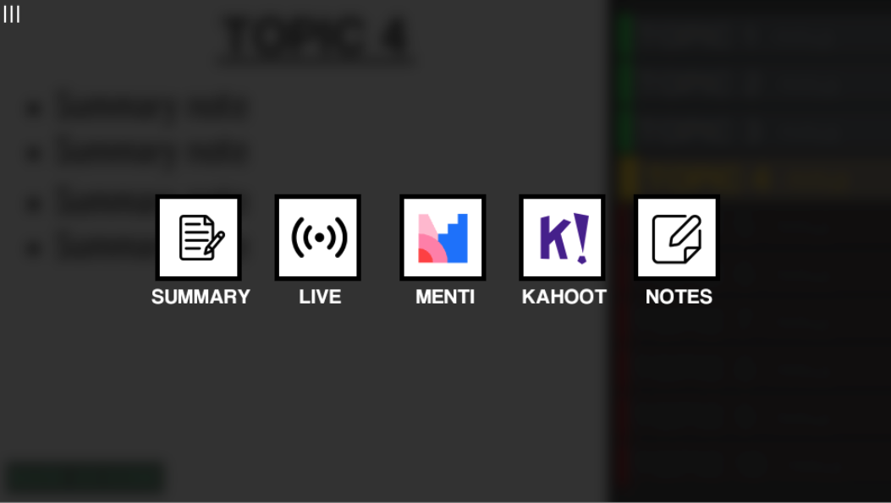

This shows how students can navigate between each task/activity. By pressing the button in the top left, the current task is blurred and darkened. Each of the 5 tasks has a button and they can be pressed to switch.

While watching the lecturer, the student also has the option to watch the lecture through a live display. This is so that students can keep up easily as well as for people who are sitting at the back who may not be able to see as clearly from that distance (see Figure 12). Additionally, a progress bar conveniently tracks the duration of the lecture, ensuring students stay informed about their session's timeline. Simultaneously, the device facilitates real-time feedback from students, employing a simple yet effective red, amber, green light system. Additionally, students have the option to provide more detailed feedback within a succinct 20-word limit. This dual feedback mechanism empowers students to express their understanding and concerns, even those hesitant to vocalize them. Leveraging this feedback loop, the lecturer can adapt the lecture dynamically, ensuring alignment with students' comprehension and addressing any emerging queries effectively.

**FIGURE 12**

